- 100 Word Profile Text
Note that a submission of a Proposal Profile constitutes a consent for that profile to be shared with registered participants. If you do not wish to submit a profile, please enter N/A.

Axiomatic_AI builds agentic AI with verification for photonic integrated circuit (PIC) design, modeling, and manufacturing at scale. Our approach leverages symbolic AI, design-space exploration, and digital twins to optimize Very Large PIC (VLPI) architectures for power, performance, and reliability. Tools include domain-specific formal languages, surrogate modeling, and verification pipelines that support both agile PIC development and long-horizon DARPA-scale architectures. Our team includes experts in photonics, AI, and formal methods from academia and industry, with ongoing efforts in photonic neuromorphic systems, 3D-optical design, and quantum-classical co-design. We seek partners in materials, foundries, CAD/EDA, and system integration.

- Would you like to schedule a Lightening Round?
Requires 1-slide lightning round presentation submitted via email. There is a limit of one (1) presentation per organization, and presentations will be limited to three (3) minutes each.

Yes. Here is what we submitted during the RFI:
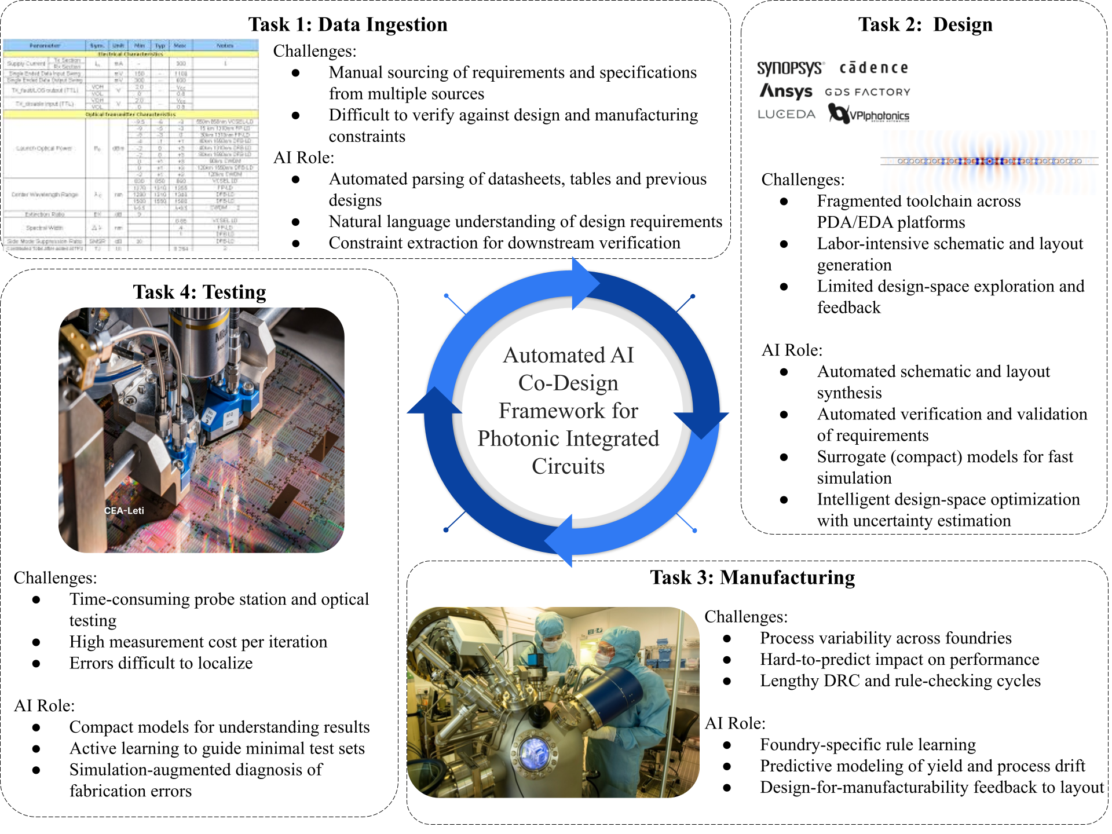

Caption: Figure 1: Overview of Axiomatic_AI approach: To meet the growing demands of scalable photonic integrated circuit (PIC) development, we are building an automated AI co-design framework that spans the entire hardware development lifecycle—from data ingestion and design to manufacturing and testing. Each phase of this pipeline presents unique challenges: fragmented design ecosystems, process variability across foundries, labor-intensive data verification, and costly, time-consuming testing cycles. Our integrated suite of AI-driven tools — The Axiomatic AI platform including the PIC Designer, Model Builder, AX ingestion assistants (AxToys) —addresses these pain points by automating routine tasks, learning from data, and incorporating verification, validation, uncertainty quantification and optimization techniques (VVUQO). Together, these components form a feedback-driven system that not only accelerates development but also improves robustness, yield, and scalability for increasingly larger and more complex photonic integrated circuits. The result is a unified and adaptive framework that automates photonic co-design enabling the development of VLPI. Image credits: All wafer and photonic circuit images used in Task 3 and Task 4 are courtesy of CEA-Leti.

- Would you like to request a Breakout Session with the Program Manager?
Breakout session with the PICASSO Program Manager during the Proposers Day are subject to time limitations. If yes, please indicate your discussion topic and participating attendees (no more than five)
Discussion topic: AI-driven co-design and verification for very large-scale photonic integrated circuits (VLPI)
Yes, following members of the Axiomatic_AI team will be participating.
- Jake Taylor(co-CEO)
- Benjamin Breen(AI Research Engineer)

